Practical 8: Binary Tree Traversals and Binary Search Tree insertion
Practical Aim
To implement binary tree traversals and binary search tree insertion, and develop the ability to reason about how the order of visiting nodes changes the information retrieved from a tree.
Problem 1
A company stores its organizational hierarchy as a tree — the CEO at the top, managers below, and employees at the leaves. Different departments need the hierarchy printed in different orders: HR wants each manager printed between their left and right sub-teams, the archive department wants each manager printed before their sub-teams, the payroll department wants each manager printed after all their sub-teams are listed, and the floor manager wants everyone printed level by level from top to bottom. Given a binary tree representing the hierarchy, implement all four printing orders and display the result of each.
Describe how your solution for level-by-level printing differs from the other three. What additional structure did you need to use, and why does the same recursive approach that works for the other three not directly apply here?
Code
https://github.com/AD-9218/DATA-STRUCUTURE-AND-ALGORITHM/blob/main/Practical-8/8_1.cpp
Output
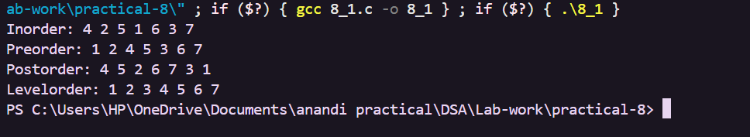
Problem 2
A school library uses a system where every book is assigned a unique code when it arrives. Books are organized so that at any shelf position, all books to the left have smaller codes and all books to the right have larger codes. This arrangement lets staff find any book quickly by always knowing which direction to look. Given a sequence of book codes arriving one by one, insert each into the correct position and print the inorder sequence after all insertions are complete.
Describe how your solution decides where to place each new book code. What property of the final inorder sequence tells you whether all insertions were performed correctly?
Code
https://github.com/AD-9218/DATA-STRUCUTURE-AND-ALGORITHM/blob/main/Practical-8/8_2.cpp

Output
Key Questions / Analysis / Interpretation
1. [Problem 1] Preorder traversal always visits the root before anything else. Using only this property — without tracing any tree — explain whether it would be possible to reconstruct the original tree from its preorder output alone, and what additional information you would need if it is not.
Answer: Preorder output alone is generally not enough to uniquely reconstruct the original binary tree because it only gives the root-before-subtrees visiting order. Additional information such as the inorder traversal, or structural information about the tree, is needed to determine how nodes are divided between the left and right subtrees.

2. [Problem 2] The inorder traversal of a correctly built BST always produces a sorted sequence. If your inorder output is not sorted after all insertions, what does that tell you about where the error is — in the insertion logic, the traversal logic, or possibly both? How would you isolate which one?
Answer: An unsorted inorder sequence indicates that either the BST insertion logic or the inorder traversal logic may contain an error. To isolate the problem, first inspect or test the insertion structure by checking whether every node satisfies the BST rule: smaller values on the left and larger values on the right. Then test inorder traversal on a manually verified BST. If traversal of the verified tree is sorted, the insertion logic is the likely source of the error; if it is still unsorted, the traversal logic is incorrect.

